

**Asignment No: 2**

**Name: Muhammad Mubbashir Khan**

**Class: ME-15 SEC (B)**

**REG no: 465077**

**Task no.1**

**Create a program that takes a student's score as input and assigns a grade based on predefined criteria using logical operators**

#include <iostream>

using namespace std;

int main()

{

// Declare a variable to store the student's score

int score;

// Prompt the user to enter the score

cout << "Enter your score: ";

cin >> score;

// Check if the score is valid (between 0 and 100)

if (score >= 0 && score <= 100)

{

// Assign a grade based on the predefined criteria using logical operators

if (score >= 90)

{

cout << "Your grade is A";

}

else if (score >= 75)

{

cout << "Your grade is B";

}

else if (score >= 60)

{

cout << "Your grade is C";

}

else if (score >= 45)

{

cout << "Your grade is D";

}

else

{

cout << "Your grade is F";

}

}

else

{

// Display an error message if the score is invalid

cout << "Invalid score. Please enter a number between 0 and 100.\n";

}

return 0;

}

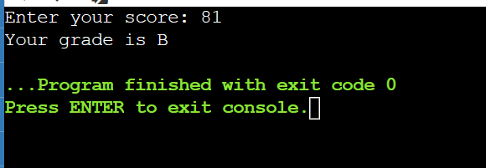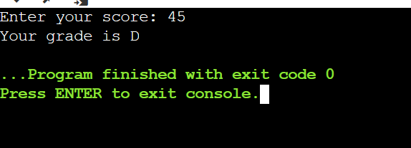

**TASK NO: 2**

**Write a program that takes an integer as input and determines if it is both even and divisible by 5.**

#include <iostream>

// This is a preprocessor directive that includes the input/output library

using namespace std;

// This is a namespace declaration that allows us to use standard names without std::

// This is the main function where the program starts

int main

{

int n; // This is a variable declaration that defines an integer variable named n

cout << "Enter an integer: "; // This is an output statement that prints a message to the standard output

cin >> n; // This is an input statement that reads an integer from the standard input and stores it in n

if (n % 2 == 0 && n % 5 == 0) // This is a conditional statement that checks if n is both even and divisible by 5

{

cout << "your integer is both even and divisible by 5"; // This is an output statement that prints a message to the standard output if the condition is true

}

else // This is an alternative branch that executes if the condition is false

{

cout << "your integer is not both even and divisible by 5"; // This is an output statement that prints a message to the standard output if the condition is false

}

return 0; // This is a return statement that ends the main function and returns 0 to indicate success

}

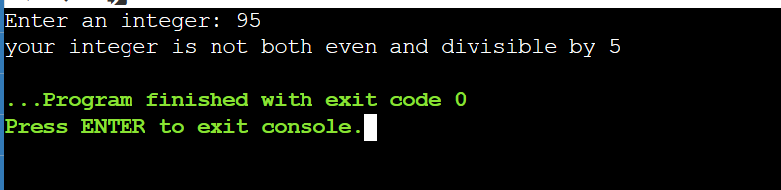

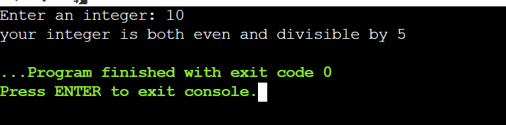

**TASK NO: 3**

**Create a C++ program that checks if a user-provided year is a leap year.**

#include <iostream> // This is a preprocessor directive that tells the compiler to include the input/output library

using namespace std; // This is a namespace declaration that allows the use of standard names without std:: prefix

int main() // This is the main function where the program execution begins

{

int n; // This is a variable declaration that defines an integer variable named n

cout << "Enter an integer: "; // This is an output statement that prints a message to the standard output stream

cin >> n; // This is an input statement that reads an integer value from the standard input stream and stores it in n

if (n % 4 == 0) // This is a conditional statement that checks if n is divisible by 4 using the modulo operator %

{

cout << " It is a leap year"; // This is an output statement that prints a message to the standard output stream if the condition is true

}

else // This is an alternative branch that executes if the condition is false

{

cout << "it is not a leap year"; // This is an output statement that prints a message to the standard output stream if the condition is false

}

return 0; // This is a return statement that terminates the main function and returns 0 to indicate successful execution

}

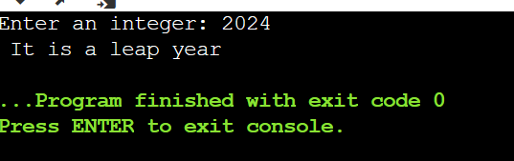

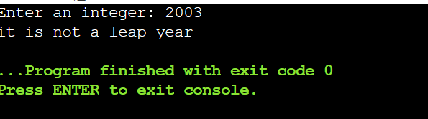

**TASK NO: 4**

**Create a C++ program that determines if a student is eligible for a scholarship based on their GPA (must have GPA >= 3.5) and attendance (must have attended at least 80% of classes)**

// Include the input/output library

#include <iostream>

// Use the standard namespace

using namespace std;

// Define the main function

int main()

{

// Declare two variables to store the GPA and attendance percentage

float gpa;

float attendance;

// Print a message asking the user to enter their GPA

cout << "Enter your GPA: ";

// Read the user input and store it in the gpa variable

cin >> gpa;

// Print a message asking the user to enter their attendance percentage

cout << "Enter your attendance percentage: ";

// Read the user input and store it in the attendance variable

cin >> attendance;

// Check if the GPA is greater than or equal to 3.5 and the attendance is greater than or equal to 80 using a logical AND operator

if (gpa >= 3.5 && attendance >= 80)

{

// If the condition is true, print a congratulatory message

cout << "Congratulations! You are eligible for a scholarship.";

}

// Otherwise, if the condition is false

else

{

// Print a sorry message

cout << "Sorry, you are not eligible for a scholarship.";

}

// Return 0 to indicate successful execution of the program

return 0;

}

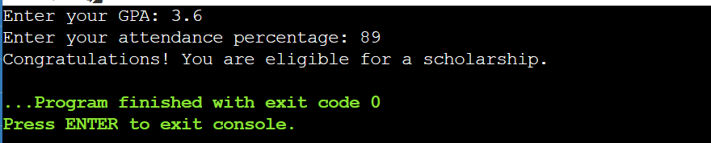

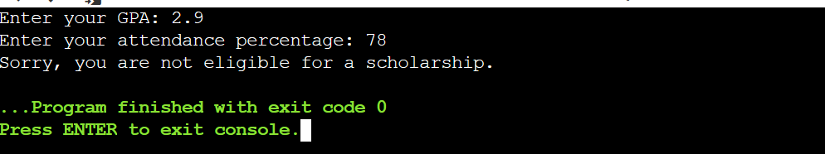

**TASK NO.5**

**Write a program that checks if a given character is a vowel (a, e, i, o, u) or a consonant using logical operators**

**// include the input/output library**

**#include <iostream>**

**// use the standard namespace**

**using namespace std;**

**// define the main function**

**int main()**

**{**

**// declare a char variable**

**char c;**

**// print a message to the user**

**cout << "Enter a character: ";**

**// read a character from the user**

**cin >> c;**

**// check if the character is a vowel (lowercase or uppercase)**

**if (c == 'a' || c == 'e' || c == 'i' || c == 'o' || c == 'u' ||**

**c == 'A' || c == 'E' || c == 'I' || c == 'O' || c == 'U')**

**{**

**// print that the character is a vowel**

**cout << c <<"is a vowel." << endl;**

**}**

**// otherwise**

**else**

**{**

**// print that the character is a consonant**

**cout << c << " is a consonant." << endl;**

**}**

**// return 0 to indicate successful execution**

**return 0;**

**}**

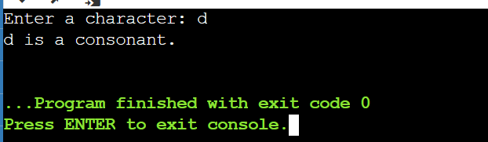

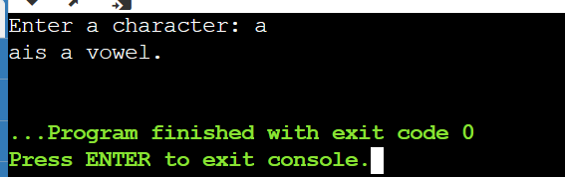

**The end**